COVID-19 (Coronavirus) and Schools | COVID-19 K-12 Resource Homepage > CARES Act
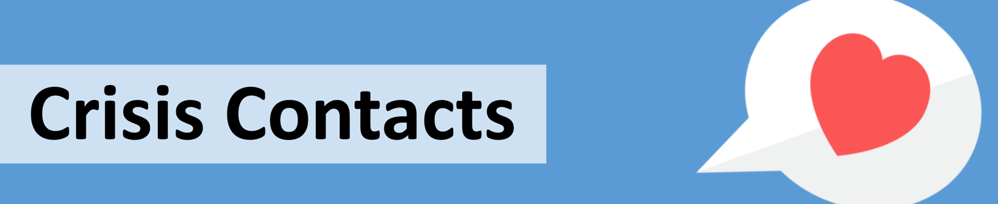
​Georgia Crisis & Access Line (GCAL) 1-800-715-4225
GCAL is available 24 hours a day, 7 days a week and 365 days a year to help you or someone you care for in a crisis.
1-855-GA-CHILD (1-855-422-4453)
Report concerns or suspected child abuse.
CRISIS TEXT LINE
Text HOME to 741741 to connect with a Crisis Counselor. Free support is available 24/7.
National Suicide Prevention Lifeline - 1-800-273-8255
The Lifeline provides 24/7, free and confidential support for people in distress, prevention and crisis resources for you or your loved ones, and best practices for professionals.
Georgia COVID-19 Emotional Support Line – 1-866-399-8938
The Georgia COVID-19 Emotional Support Line provides 24/7 free and confidential assistance to callers needing emotional support or resource information as a result of the COVID-19 pandemic. The Emotional Support Line is staffed by volunteers, including mental health professionals and others who have received training in crisis counseling.
CARES Warm Line - 1-8 4 4 -326-54 00 (8:30AM - 11:00PM)
Call or text the CARES Warm Line for substance abuse challenges every day of the year.
COVID-19 Hotline - (8 4 4 ) 4 4 2 -2681
The State of Georgia has a new COVID-19 hotline. If you believe that you are experiencing symptoms of COVID-19 or have been exposed to the novel coronavirus, please contact your primary care doctor or an urgent care clinic. Please do not show up unannounced at an emergency room or health care facility.
Peer2Peer Warm Line - 888-945-1414
The Warm Line provides Georgians the opportunity to receive peer support over the phone 24 hours a day.
SAMHSA’s National Helpline - 1-800-662-HELP (4357)
Free, completely confidential, and available 24/7/365, this service from the Substance Abuse and Mental Health Services Administration (SAMHSA) can help you find treatment facilities, support groups, and community-based organizations in your area.
National Domestic Violence Hotline - 1-800-799-7233
Highly trained expert advocates are available 24/7 to talk confidentially with anyone in the United States who is experiencing domestic violence, seeking resources or information, or questioning unhealthy aspects of their relationship.

